**1. Data Collection and Exploration**

**1. a. Study Summary**

Since clouds play an important role in modulating the sensitivity of the Arctic to increasing surface air temperatures, it is important to characterize them. The goal of this research is to build cloud detection algorithms, combining clustering and classification methods.

The data is collected from MISR, which has nine cameras and views the Earth at a different angle in four spectral bands. 233 geographically distinct MISR paths are collected on a repeat cycle of 16 days. Each complete trip of MISR is an orbit, and each MISR pixel covers 275m x 275m region on the ground. For this study, only the red radiances and al channels are full resolution, whereas the others are aggregated to a 1.1km x 1.1km resolution.

More specifically, the data were collected from 10 MISR orbits of path 26 over the Arctic, northern Greenland, and Baffin Bay. The time span includes 144 days in 2002. There are six data units from each orbit, with 3 of 60 units excluded, so in total 57 data units with approximately 7.1 million 1.1-km resolution pixels with 36 radiation measurements for each pixel. Among 57 units, 5 million pixels are labeled by the expert and offline SVM is trained on 20k random expert labels from 20 data units and tested on remaining 37.

Three main features were used to assess the ELCM algorithm developed in this study: CORR, SD, and NDAI. It was concluded that ELCM algorithm is more accurate and provides better spatial coverage than existing MISR algorithms for cloud detection in the Arctic. The ELCM algorithm agreement rate was about 10% higher than the existing algorithms, and had 100% coverage rate, which is significantly higher than the others.

    This study is significant because it can be applied to other scientific problems such as hurricane prediction and climate change. Also, it depicts the power of statistical thinking and the ability of statistics to contribute to modern, pressing scientific problems including environmental concerns.

**1. b. Data Basics**

Each image is of size 382×305382×305 pixels, and each pixel represents a 275×275m275×275m window of earth surface. For each pixel, our dataset documents its x,y coordinates, an expert label indicating whether the pixel is clouded, five angular radiance readings from MISR satellite, and three custom-created features capturing inter-pixel or inter-angular-channel dependencies.

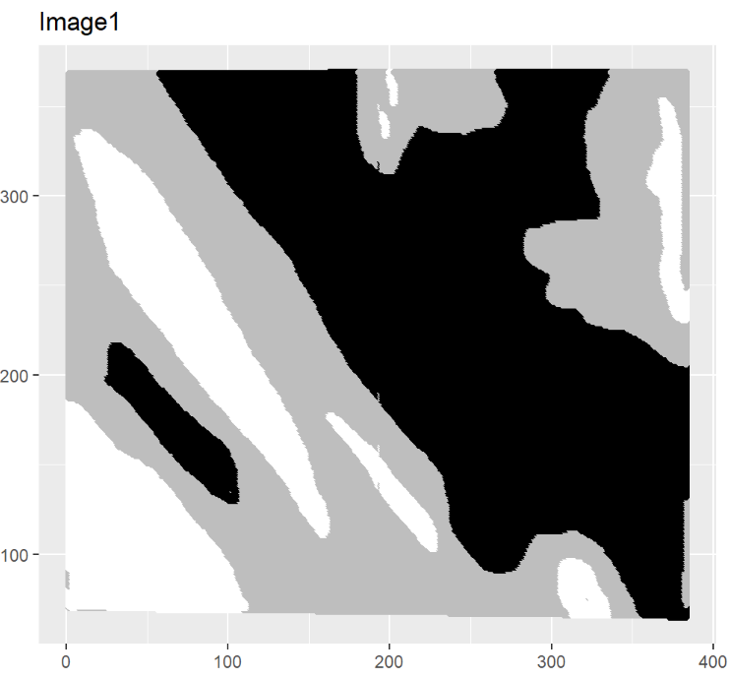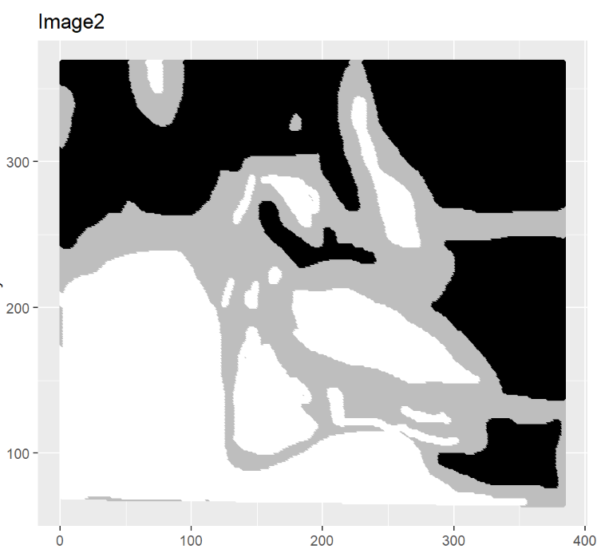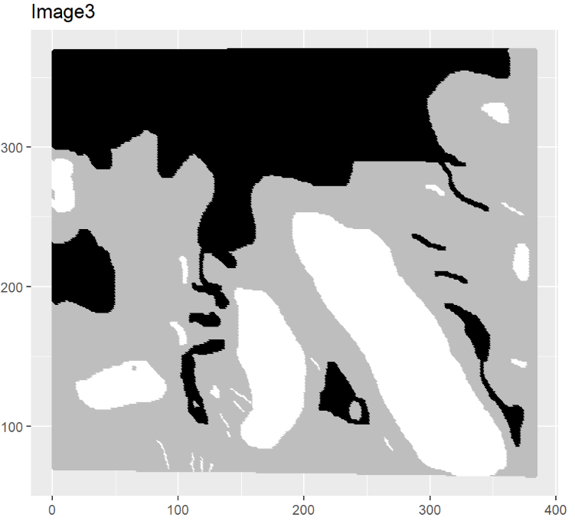

A quick recreation of the three images is shown above, with black representing pixels not clouded, white clouded and grey not confident enough to judge. As we can see, all three pictures have a rather significant portion of pixels that experts cannot confidently label: image1 has 38% grey, image2 28% and image3 52%. These undetermined pixels contain no useful information about cloud existence, and therefore cannot be used in either training or testing.

Should we just throw them away? One might be concerned that a simple discard would break spatial/geological dependency, leading to worse parameter estimation. Our counter argument is that for basic Generalized Linear Models (logistics, LDA/QDA) that don’t explicitly take into account the local interactions between variables, **sporadically** deleting some samples wouldn’t degrade the model quality by much. Basic linear paradigms all assume some smooth global relationships between the class posteriors and the features; such global smoothness constraint implies the functions are unlikely to have irregular local behavior. So as long as our remaining samples can loosely cover the feature space, we can afford to delete some samples.

Of course, a better fix would be to go back to data collection stage, and augment these unlabeled pixels with more meaningful information, such as the confidence level with which the pixel is clouded. Under proper justification from prior knowledge, we might be able to use that confidence level as a surrogate for the class posterior, and produce a more informative model.

**1. c. EDA**

Summary of the merged data frame of the three images is shown on the left. Pair-wise scatterplot between custom-created features is displayed on the right.

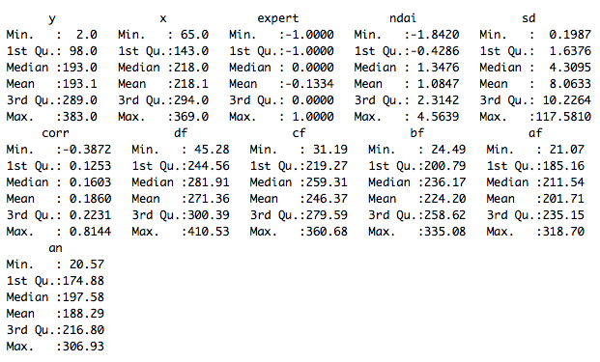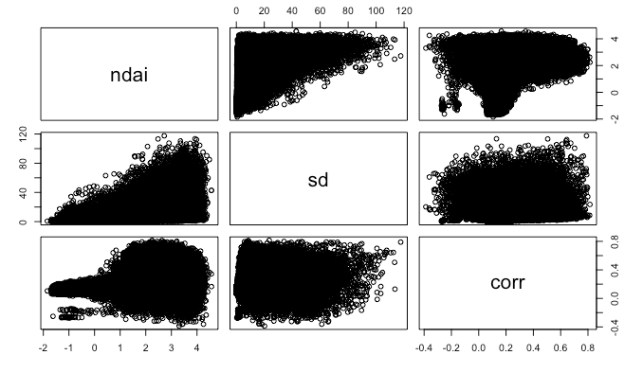

**2. Preparation**

**2. a. Data Splitting**

* Test Set?

Both ways of splitting use the entire image3 as the test set. This is to best simulate real-life prediction scenarios, where the actual test picture always comes in individually. If we had created the test set using partial information from all three images, then we would have introduced some form of spatial correlation between training and test dataset that doesn’t exist in a real prediction setting. For models that are able to pick up such correlation, our test set would yield a potentially higher accuracy rate than a real-life test set would.

The tradeoff is of course we are losing around 30% samples to training. Nevertheless, given that the sample size is already large, we decided to stress the structural integrity of the test set.

* Training vs Validation Set: Method One

Method: Divide each image into four quadrants, so we have 8 quadrants in total. Pick one as validation, and leave the other seven as training.

Rationale: Training set preserves space-based structure; Validation set covers unbalanced cases.

In analogy to time series data, randomly spitted training data would only partially preserve space-based structures, if such structures do exist. For models that pick up space-based dependency, this would hurt the quality of parameter estimation. By dividing each image quadrant-wise, we’re attempting to best preserve any space-based structure.

Our validation set turns out to be unbalanced. But that doesn’t disqualify the quadrant from being a proper validation set: an unbalanced/distorted validation set can identify the model that performs well on unbalanced data. In practice we should expect some test data to be highly imbalanced, as clouds can be very large.

* Training vs Validation Set: Method Two

Method: We randomly sampled from each quadrant an equal amount (1/8 of total) of pixels, use them for validation, and the rest for training. In this manner, each quadrant is equally represented.

Rationale: Generalizing to potentially defected images.

**2. b. Null Classifier**

The validation accuracy will be 0.65 and the test accuracy will be 0.61 for a trivial classifier. Such classifier will have a high accuracy only in datasets that have the majority of the data points classified as being cloud-free (expert label=-1).

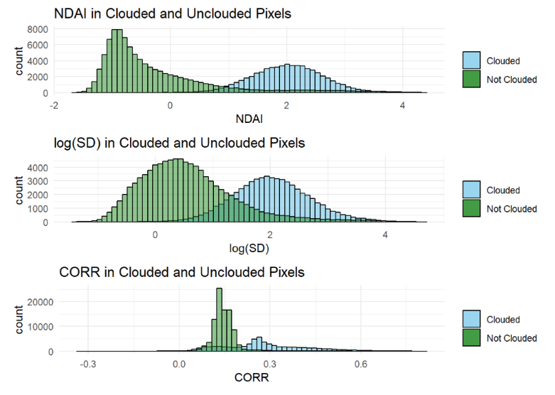**2. c. First Order Importance**

If a feature performs very differently between clouded and not clouded pixels, then it likely has some predictive power. We look at summary statistics for a quick search of suspects. For each potentially influential feature, we histogram its respective distributions among clouded and unclouded pixels, and see if the two distributions are separate enough to give any predictive power.

The mean and median of NDAI, SD and CORR are all significantly higher among clouded pixels than non-clouded pixels. Histograms conditioned on cloud existence also look promisingly separate – for each of the three features, there exists some non-trivial feature range for which the class posterior P(Y=1|Xj=x) (where Xj denotes the jth component the complete feature vector) is dominatingly high. Note that although the separateness of conditional distributions provide some intuitive justification for some thresholding scheme, it doesn’t provide the threshold values. We need an in-depth analysis of the class posterior conditioned jointly on the three features to establish proper thresholds.

**2. d. Cross Validation Function**

Please see report/report.Rmd or code/CVgeneric.R for important limitations on input data types, fold-creation methods, and admissible models. Both copies are identical except that code/CVgeneric.R contains some manual testing.

**3. Model Fitting**

We won’t touch the test set in this part. This is to ensure the model selection is completely based on using available data, which best mimics a real-life prediction situation.

**3. a. Model Fitting**

We’re following 4 model-fitting schemes, where each of them is distinguished through different set of hyperparameter(s):

**i. Penalized Logistics Regression with both L1 and L2 penalty**. This is analogous to elastic net in Regression. Hyperparameters are weights of both penalty, and the overall strength of penalty represented by the sum of weights.

**ii. RDA(Regularized Discriminant Analysis)**, a generalization of LDA/QDA where one adjusts the homogeneity of the shapes of conditional dispersion of features.

**iii. LDA with feature selection.** This is analogous to what Yuansi did for AmesHousing.

**iv. Random Forest**, which yields non-linear boundaries.

For each scheme, we will choose a basket of hyperparameter values, fit the model for each combination of hyperparameters, check if the assumptions are satisfied, and use cross validation (both K-fold and validation set) to pick the potentially optimal choice of hyperparameters.

1. **Penalized Logistics Regression**

???

1. **Regularized Discriminant Analysis**

LDA model assumes each sample’s features are generated through a multivariate mixed-Gaussian, and that their class-conditioned distributions share the same covariance but differ in mean. Geometrically, this means that for each class, any generated data cloud (in feature space, with suffciently large sample size) would be the shape of an ellipsoid, and that such ellipsoids for different classes only differ in mean but not in shape. QDA, on the other hand, allows each class’s ellipsoid to have completely different shapes.

RDA falls in between the spectrum. It models each class’s variance using a weighted average of global covariance and class-specific covariance: ΣRDAk=αΣ+(1−α)Σk, and thus allows class-specific ellipsoids to possess flexible degree of homogeneity in shape. Hyperparameter ααrepresents the strength of shape-homogeneity.

We cross-validate over five α values: 0 (which yields the LDA model), 0.25, 0.5, 0.75 and 1(which yields the QDA model).

**Feature selection:** We only use CORR, NDAI and log(SD)(log to disperse the distribution of SD) for RDA fitting. Testing Gaussian-ness in high dimension is hard, but if we keep the dimension of feature to three, we might use some visualization technique to justify the Gaussian-ness.

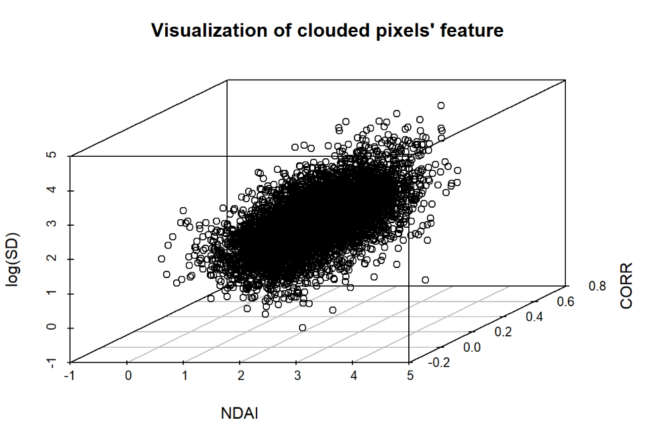**Testing of Assumptions:** We did a quick 3D sketch of feature space for clouded pixels (for the randomly spitted validation set), where ellipsoidal dispersion looks reasonable; we also sketched its projections onto pair-wise feature space (graph not included to save space), and the elliptic shapes once again show up. The same pattern is observed among unclouded pixels. We have reasons to believe the Gaussian-need of conditional distribution of features.

Professor Yu mentioned in class that even models that don’t satisfy their own assumptions can prove to be useful predictive scheme. So the assumption testing isn’t of paramount importance here. We focus on other model selection metrics.

**Cross validation:** We do two types of cross validation. First one is K-fold, the other one is single validation set. For K-fold, we report the average loss across folds, and also the time consumption. For the validation set approach, we report the errors on two different validation sets, one sampled randomly and the other one not. As we explained in Q2 part a, we expect the non-random set to identify the method’s strength over potentially unbalanced data, and the random set for general data.

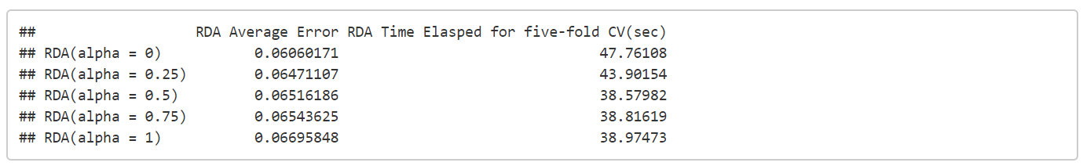

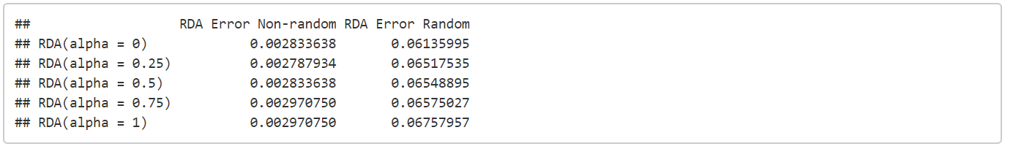 Computation-wise, all five models perform similarly. For both randomly sampled validation set and the K-fold, RDA with α=0 (which is exactly the LDA model) wins in accuracy. RDA with α=0.25 performs slightly better over unbalanced data. We keep these two candidates in mind.

**iii. LDA with feature selection.**

Does it make sense to only consider the three custom-created features? Would inclusion of geological information(x and y) help improve the model quality? What about the raw radiation readings?

In this subsection, we attempt to address these natural concerns by cross validating over four models: LDA that only includes custom features, one that has custom+geological features, another one with custom+radiation_reading, and the full model.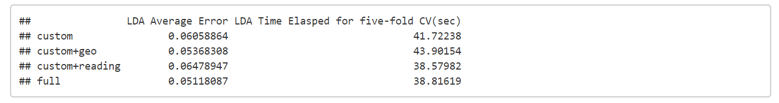

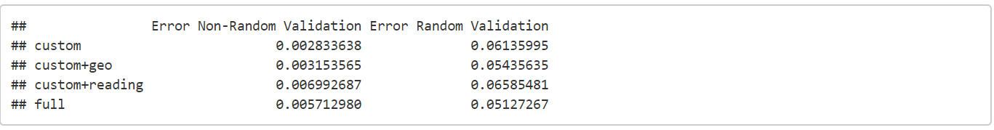

Again, computationally all four models perform similarly. For validation error over generic data, custom+geo model performs best. The LDA that only includes the three custom features only performs best for validation over non-random validation. This means that geological information isn’t useless!

Our winners here are custom+geo and custom.

**iv. Random Forest**

**???**

**3. b. ROC curve**

ROC curve tells us about a model’s false positive and false negative rate. In part a) we picked the models with the best overall error rate (over different validation sets). In this part b) we will use the false positive and false negative rate as a thresholding mechnism – as long as a candidate model doesn’t perform too poorly in terms of type I or type II error, we will regard the model as admissible.

We use the randomly-sampled validation set to calculate the false postive and negative rate for each method. We arbitrarily set both thresholds at 10% = 0.1, meaning if either false positive or false negative rate is higher than 0.1, we discard the model.

PICTURES FOR ROC CURVE

As we don’t use ROC curve to pick the threshold, we only display them for the sake of completeness. ROC curves for random forest and logistics regression are shown below. The curves for LDA with tuned features and RDA are similar to that of logistics.

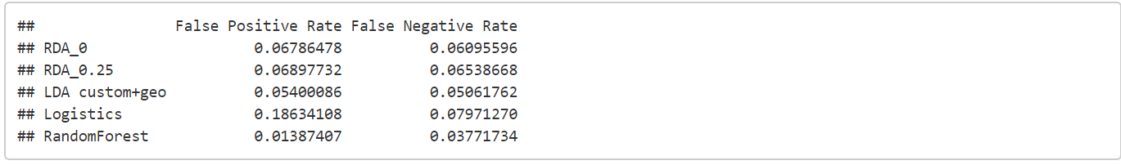

The table below shows false positive and negative rate. The logistics model has a false positive rate of 0.18, which is higher than our 0.1 bar. We won’t use logistics model for prediction purpose.

**4. Model Diagnostics**

We did the diagnostics in Part3 using validation set only. In Part4 we reintroduce the test set to see how models perform in real-life setting.

**4. a. Further diagnostics on candidate models**

In Part3 we find that Random Forest performs best in accuracy (~97%), but takes about 3min to train (for our validation/training split). LDA and RDA models have slightly lower accuracy (~95%), but their training takes only 40+sec. Penalized logistics is similar in overall accuracy to linear discriminant models, but its false-positive error is quite high.

In this subsection, we use three metrics: test-time performance, interpretability of features, and stability under perturbed training data.

**Test-time Accuracy:** All three RDA models perform way worse on test sets than in validation set, each having error rate over 21%. Even though we arrived at the three linear discriminant models from different thought process(one from feature selection, two from regularization tuning), they are similar in nature, and in test-time performance. For simplicity’s sake we will just use the LDA model with custom+geo features.

The Random Forest model performs relatively better, showing an test-time error rate around 16%. If the goal is accuracy alone, we would recommend Random Forest.

**Interpretability & Feature Importance: ????**

**Stability under perturbed training data:** We perturb a part of the training image by randomly sampling one percent of useful pixels from image1, and flip their labels. The effects are shown below. We then re-train the model using perturbed training set, and report its test accuracy.

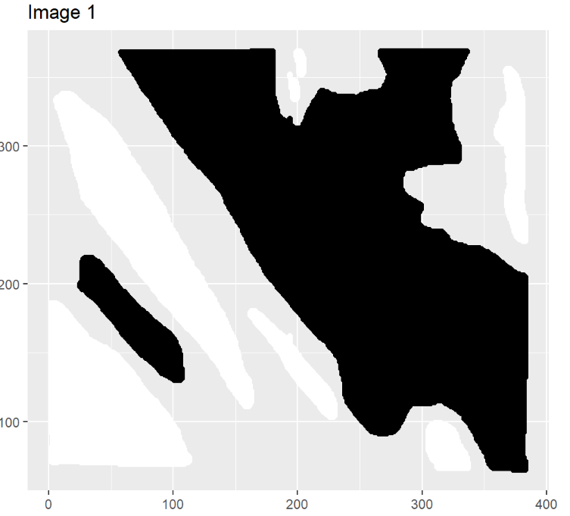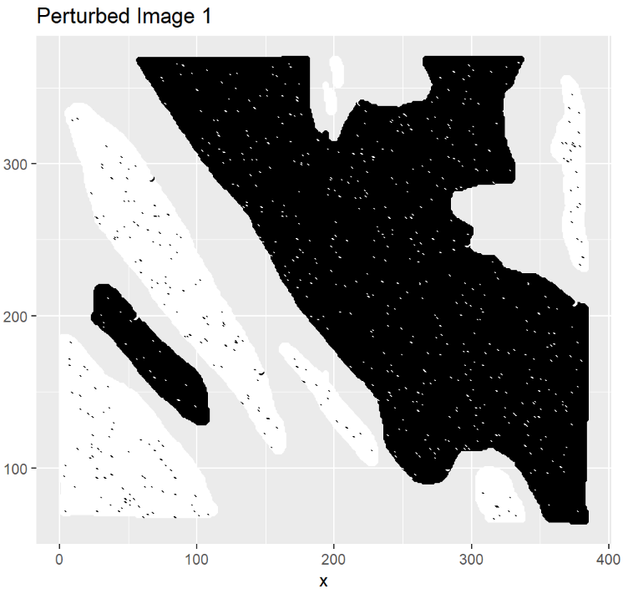

It turns out for the LDA model with custom+geo features, the perturbed error is 0.24, a bit lower than the actual error 0.25. We repeat the experiment about ten times, and each time the perturbed error is around 0.24. We can thus conclude that the LDA model is robust under perturbance.

For Random Forest, the perturbed error falls within the range of 0.12-0.18. For stability purpose, we would recommend the LDA model using custom features + (x,y) coordinates.

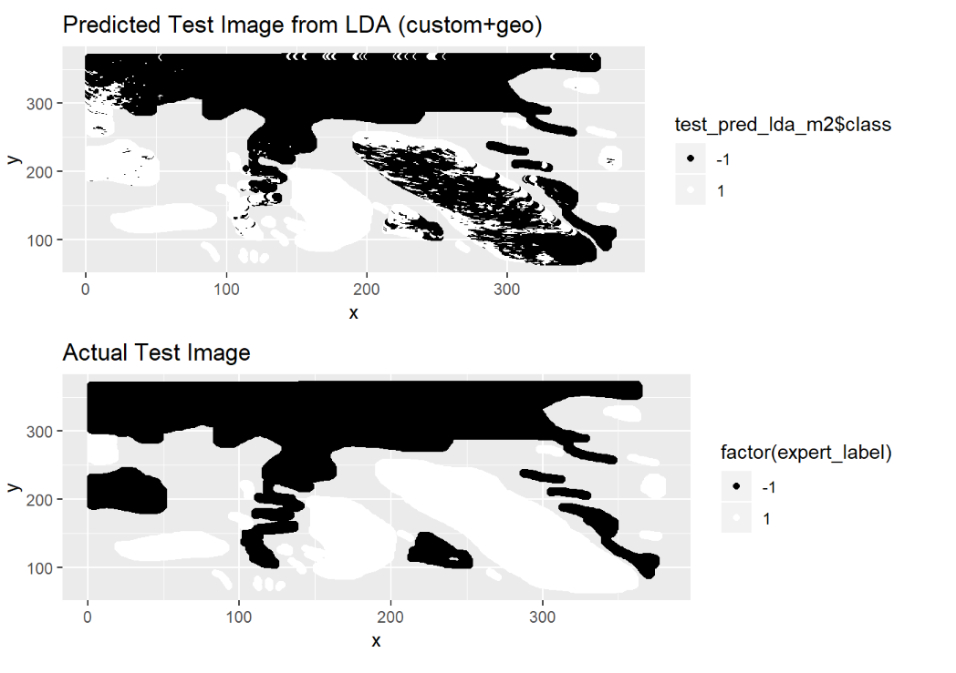**4. b. Graphical distribution of misclassifications**

A comparison between predicted image and the actual test image is shown below. For the LDA model, the error concentrates in two parts: one small patch near the left boundary is falsely positive, and a big patch in the fourth quadrant is false negative.

We think that the culprit for such concentrated errors is imbalance in training data. Looking back at image1 and image2, we realize in both images the left patch is mostly white, and the bottom right corners are mostly black. Such problem might be addressed through including more images in the training dataset.

**4. c. Can we improve?**

**????**

**4. d. Does data splitting matter?**

Not by much, as long as we’re using image3 as the test set. It makes sense because neither logistics nor RDA models in our implementation contains interaction terms, and thus ignore any space-based structures.

**4. e. Conclusions**

For accuracy, use Random Forest.

For stability, use LDA.

For interpretability, use logistics.

Include more images in training to avoid concentrated errors.